Resume

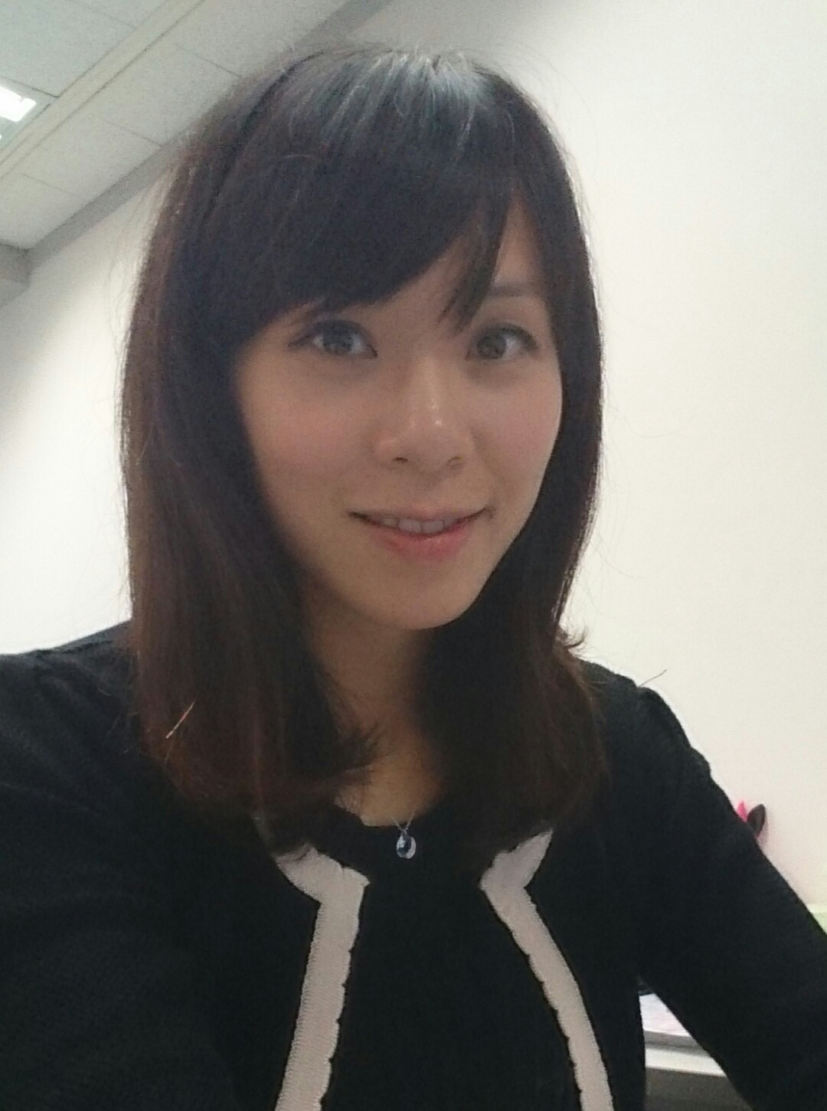

CHE, Kit Ying, Jess (車潔瑩)
2/F, House 203,
Tai Hang Fui Sha Wai,
Taipo, N.T.
Mobile: +852 9123 5472

Personal Particulars:
Gender : Female
Date of Birth : 18th Nov, 1987
Email Address : jesskyche@gmail.com

Education:
1999-2006 : Form 1-7, Sung Lan Middle School

2010-2014 : BTEC Higher National Diploma in Business

May 2015 : Bachelor of Business Administration,
University of Bedfordshire, UK

Working Experience:

Jan 14 to NOW
Group Executive Secretary - Hospital Authority Provident Fund Scheme
The Scheme manages investment portfolios for HA employees, hiring investment managers from all over the world in different markets and categories.

- Provide secretarial support to the Scheme Executives as well as investment analyst team
- Oversee office admin and HR work e.g. office renovation; update and implement office policies, manage staff attendance records, liaise with service providers etc.
- Liaise with a group of JPs, Bankers, University Professors, Doctors and Government Representative.
- Liaise with internal and external parties, such as HA Head Office, Fund Houses, and Investment Managers etc.
- Arranging HA events, such as boards meetings
- Prepare business correspondence, presentation materials and management reports
- Schedule and coordinate appointments, meetings, travel itineraries
- Ensure company compliance records are well updated
- Assist in ad-hoc projects as assigned

Mar 13 to Jan 14
Administrative Assistant - Hyundai Securities (Asia) Limited
Korean Securities House
Size : 20 expatriates
Reason for leaving: Resignation, Korean Boss returned to home country

- Work as a PA for the Head of Asia (Korean Expatriate)
- Helping the boss and his family arranging personal matters such as
child education, family trip, personal finance etc.
- Provide secretarial support to a team of Equity Sales, Research Analysts, Bonds trader as well as Warrant team
- Schedule and coordinate appointments, meetings, travel itineraries , road shows and corporate weeks
- Prepare business correspondence, presentation materials and management reports
- Organizing Large-scale Cooperate events such as Corporate weeks, NDRs
- Apply the Staff and their family working visas
- Handling all-rounded office administrative works (e.g. Rental, business cards, payment, checks issuing etc.)
- Preparing Daily Settlement reports
- Assist in ad-hoc projects as assigned

Mar 11 to Mar 13
Administration Officer - China Construction Bank International
Chinese Investment Bank
Size : 400 employees
(Employed as receptionist at the beginning)

Reason for leaving: Resignation

．Manage a range of administration works such as office relocation, renovation, drafting guidelines& plan, tele-communication system, teleconferencing, office cleaning, company insurance, plant caring, invoices, and stationary ordering
．Processing invoices and maintaining the relationship for external vendors
．Organize the details of special events (e.g. Board meeting, Annual Dinner), travel arrangement, agendas and itineraries.
．Supervise a team of receptionists
．Arranging the reception service for VIPs
．Assist the Head of Admin for drafting and review procedures and policies
．Preparing expenses claim for departmental directors
．Help and assist CEO’s secretary
．Help in Ac-hoc projects (eg. Annual dinner)

Nov 07 to Mar 11
Cabin Attendant – Japan Airlines; Hong Kong Airlines

Computer skills:
WINDOWS, Microsoft Word, Excel, PowerPoint, Outlook

Language:
Cantonese, English, Mandarin, intermediate level of Japanese

Notification Period: 2 month notice

Expected Salary: 33 K (negotiable)

Current Salary: 28.7 K X 12 mths
(With 15% of annual income as guaranteed gratuity, average 33K per month)

